Test Case: tc002_SPX_Dev5_Crear_Requisicion_Spot_Con_FAD_Tipo_Cobro_CC
Step 1 - Enter username and password and click to button Enter : Credentials Entered
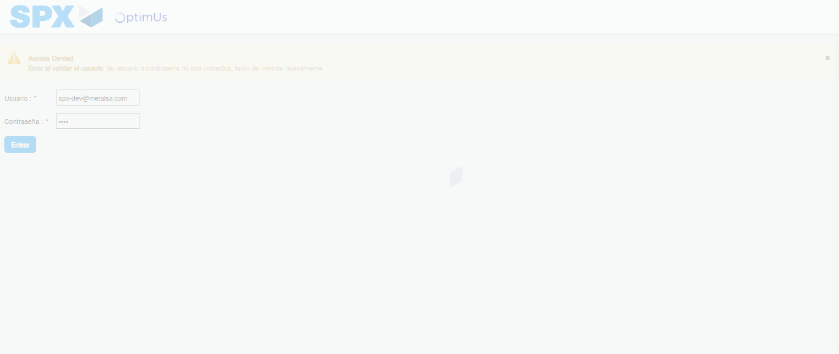Image file-name: QC_Testing-tc002_SPX_Dev5_Crear_Requisicion_Spot_Con_FAD_Tipo_Cobro_CC-1790178690367

Step 2 - Select to UEN and Access to Spot Buy Requisitions : UEN Correctly selected and Correct access
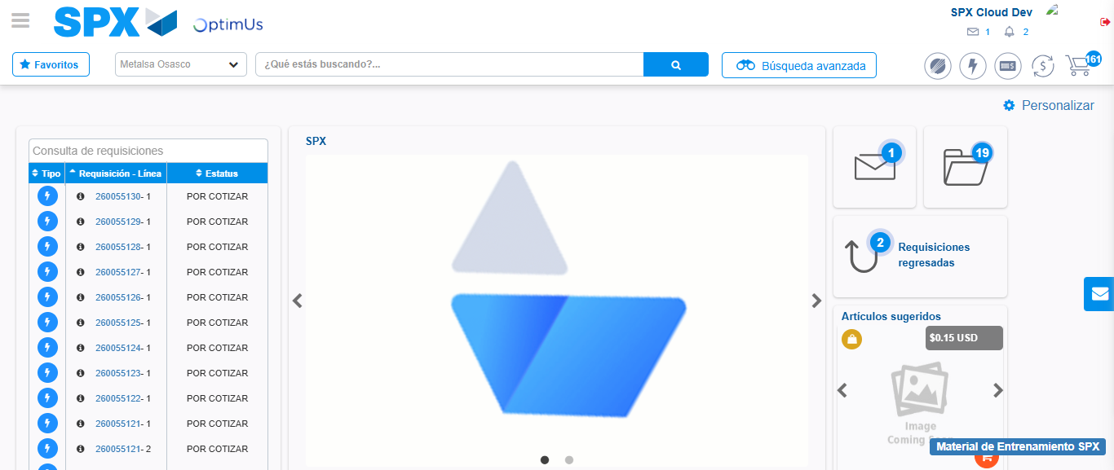Image file-name: QC_Testing-tc002_SPX_Dev5_Crear_Requisicion_Spot_Con_FAD_Tipo_Cobro_CC-1790178713919

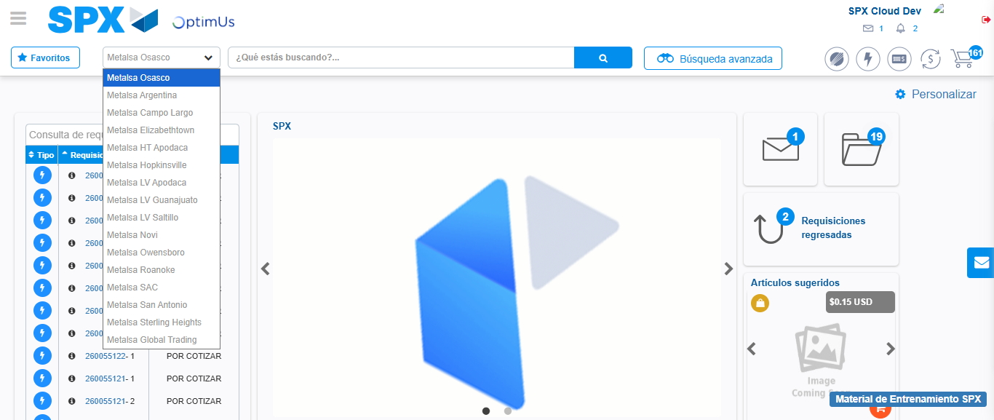Image file-name: QC_Testing-tc002_SPX_Dev5_Crear_Requisicion_Spot_Con_FAD_Tipo_Cobro_CC-1790178714398

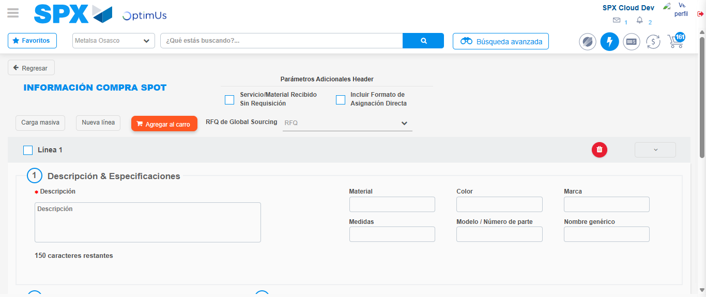Image file-name: QC_Testing-tc002_SPX_Dev5_Crear_Requisicion_Spot_Con_FAD_Tipo_Cobro_CC-1790178719846

Step 3 - Add FAD to Requisition: FAD Successfully Added
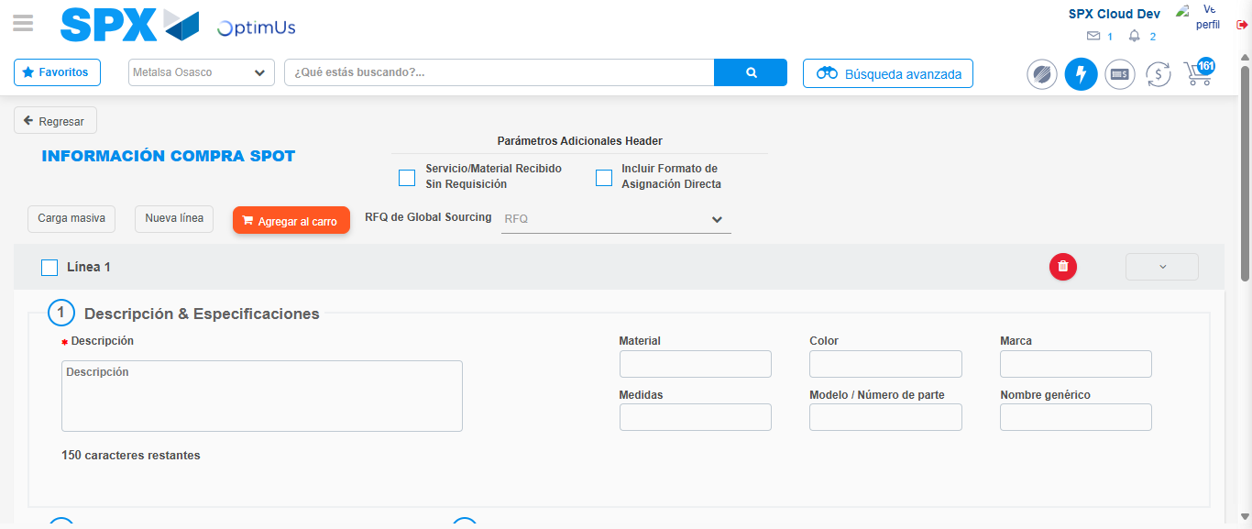Image file-name: QC_Testing-tc002_SPX_Dev5_Crear_Requisicion_Spot_Con_FAD_Tipo_Cobro_CC-1790178720099

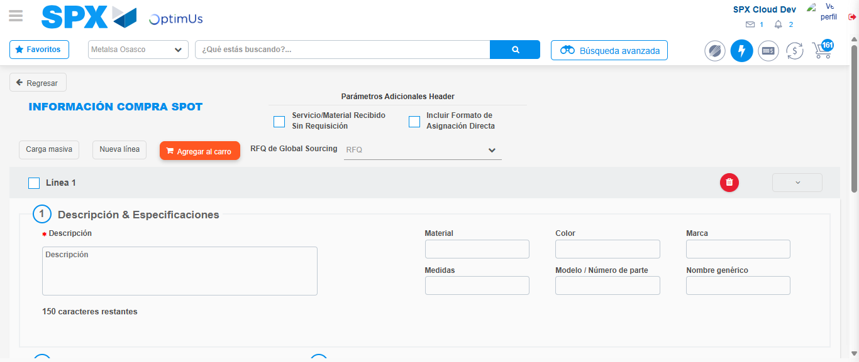Image file-name: QC_Testing-tc002_SPX_Dev5_Crear_Requisicion_Spot_Con_FAD_Tipo_Cobro_CC-1790178720324

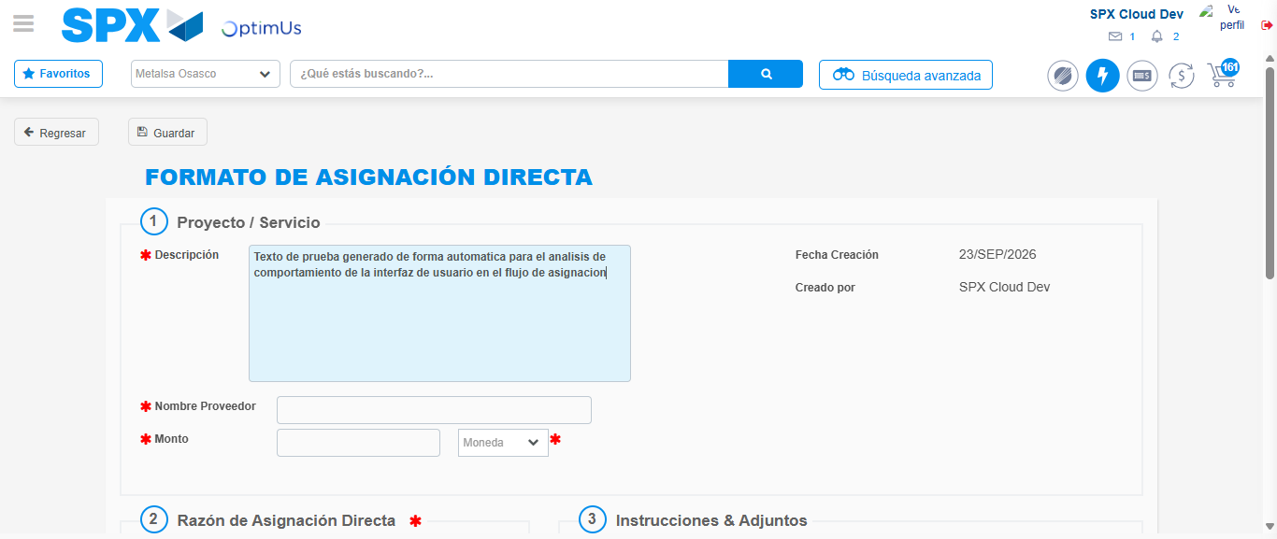Image file-name: QC_Testing-tc002_SPX_Dev5_Crear_Requisicion_Spot_Con_FAD_Tipo_Cobro_CC-1790178723006

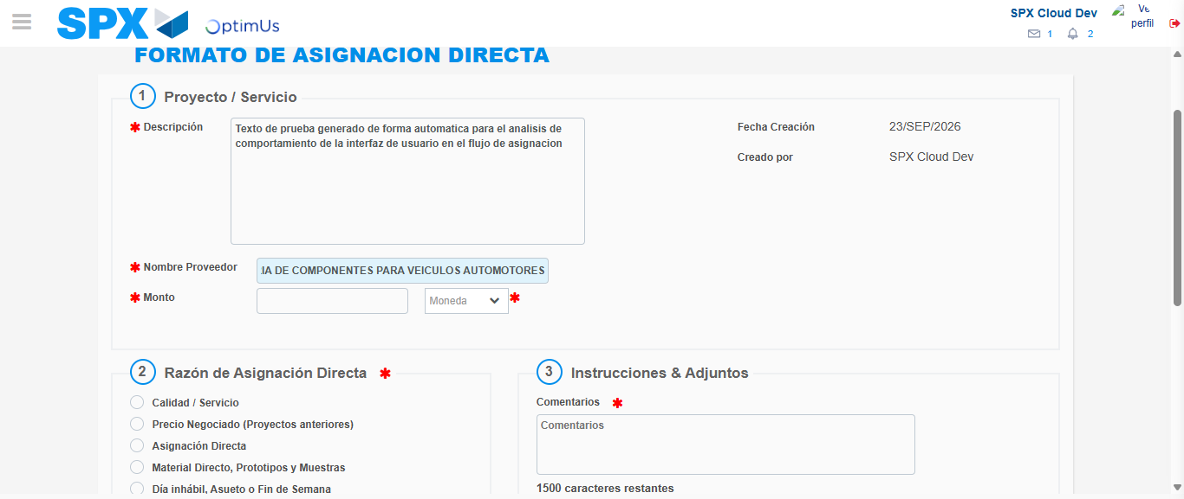Image file-name: QC_Testing-tc002_SPX_Dev5_Crear_Requisicion_Spot_Con_FAD_Tipo_Cobro_CC-1790178731295

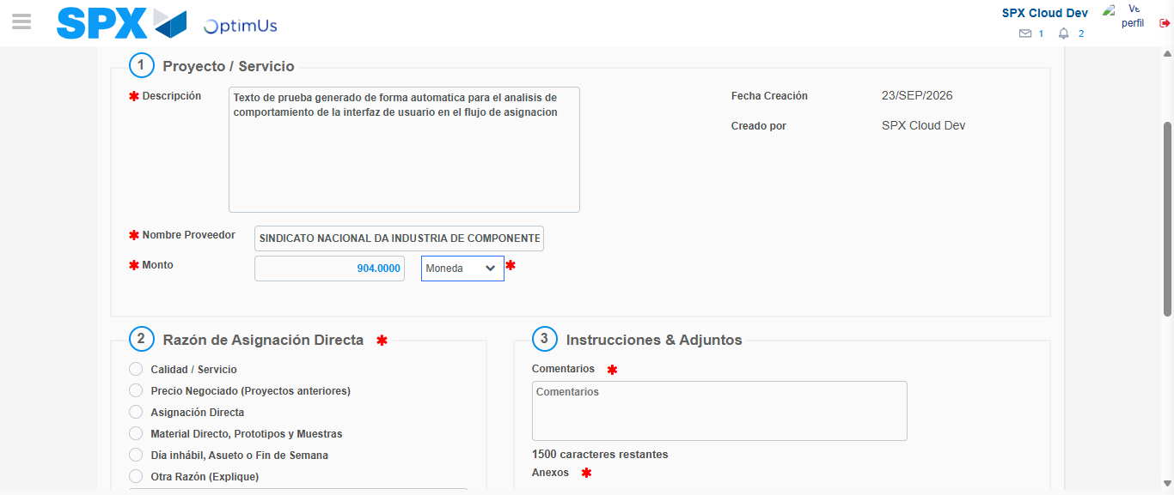Image file-name: QC_Testing-tc002_SPX_Dev5_Crear_Requisicion_Spot_Con_FAD_Tipo_Cobro_CC-1790178731635

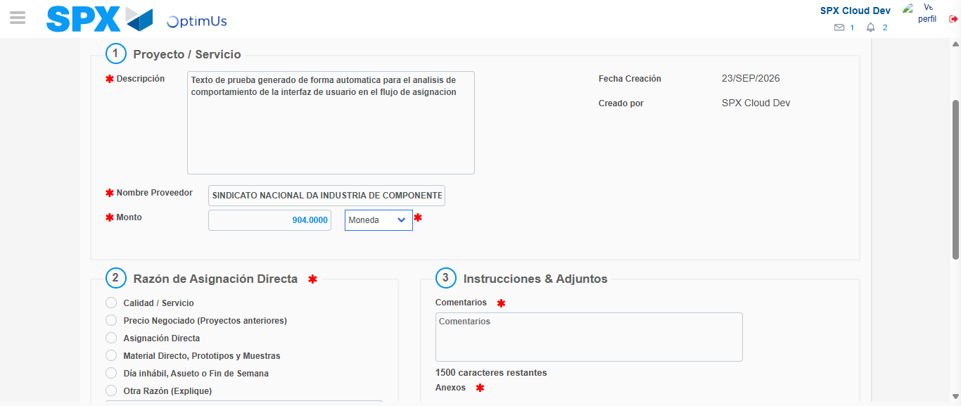Image file-name: QC_Testing-tc002_SPX_Dev5_Crear_Requisicion_Spot_Con_FAD_Tipo_Cobro_CC-1790178731840

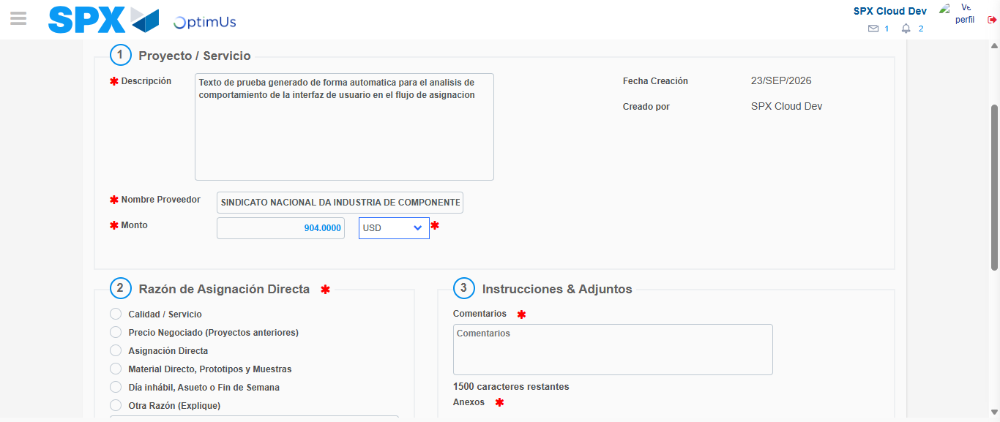Image file-name: QC_Testing-tc002_SPX_Dev5_Crear_Requisicion_Spot_Con_FAD_Tipo_Cobro_CC-1790178732139

Image file-name: QC_Testing-tc002_SPX_Dev5_Crear_Requisicion_Spot_Con_FAD_Tipo_Cobro_CC-1790178732321

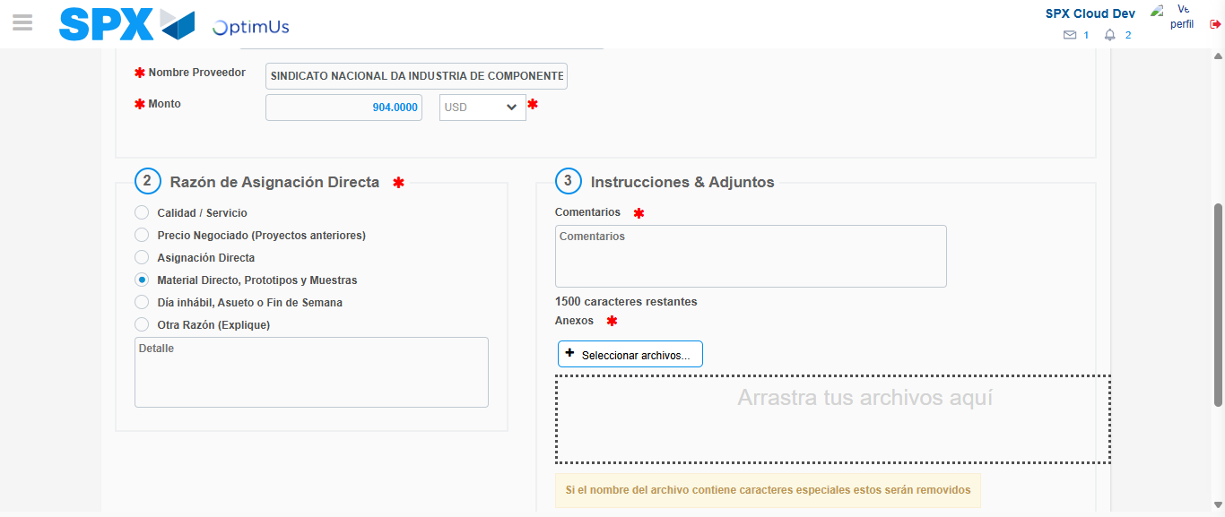Image file-name: QC_Testing-tc002_SPX_Dev5_Crear_Requisicion_Spot_Con_FAD_Tipo_Cobro_CC-1790178733096

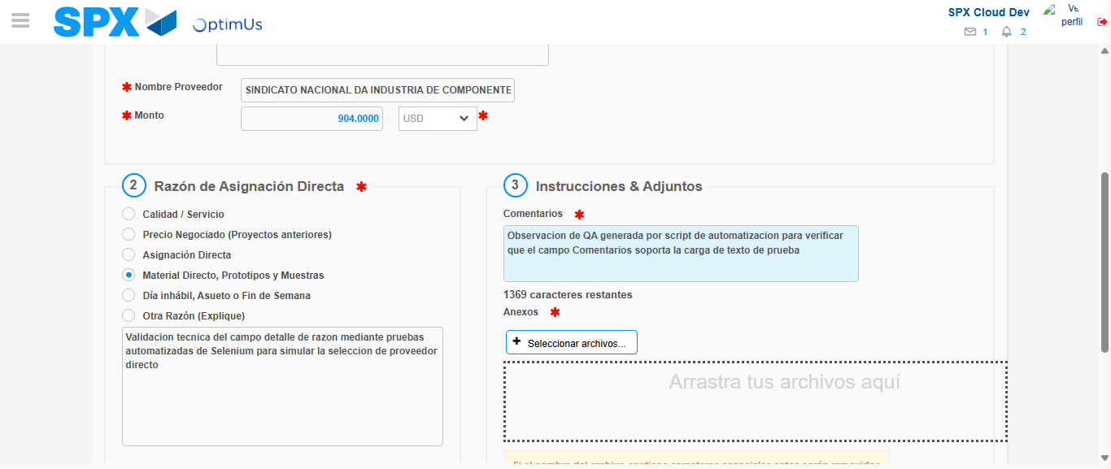Image file-name: QC_Testing-tc002_SPX_Dev5_Crear_Requisicion_Spot_Con_FAD_Tipo_Cobro_CC-1790178744036

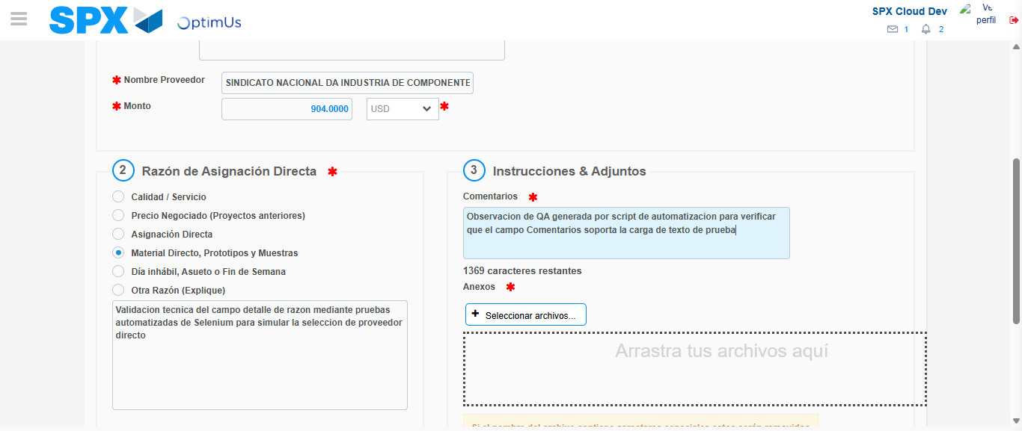Image file-name: QC_Testing-tc002_SPX_Dev5_Crear_Requisicion_Spot_Con_FAD_Tipo_Cobro_CC-1790178744582

Step 4 - Data Capture Spot Buy Requisition: Data captured correctly
Image file-name: QC_Testing-tc002_SPX_Dev5_Crear_Requisicion_Spot_Con_FAD_Tipo_Cobro_CC-1790178720099

Image file-name: QC_Testing-tc002_SPX_Dev5_Crear_Requisicion_Spot_Con_FAD_Tipo_Cobro_CC-1790178720324

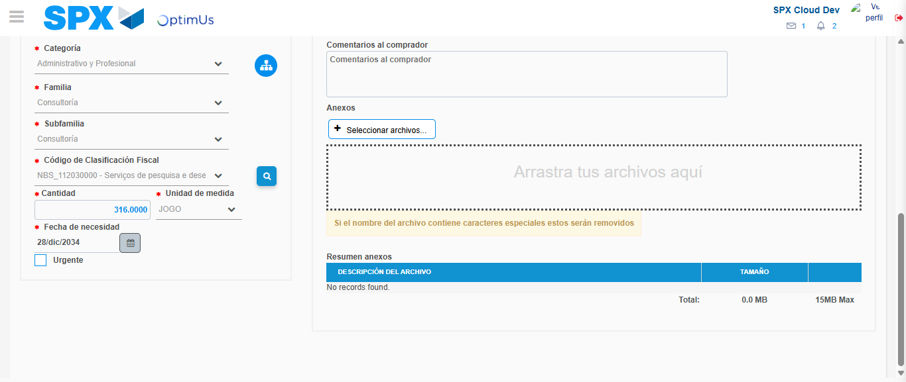Image file-name: QC_Testing-tc002_SPX_Dev5_Crear_Requisicion_Spot_Con_FAD_Tipo_Cobro_CC-1790178762596

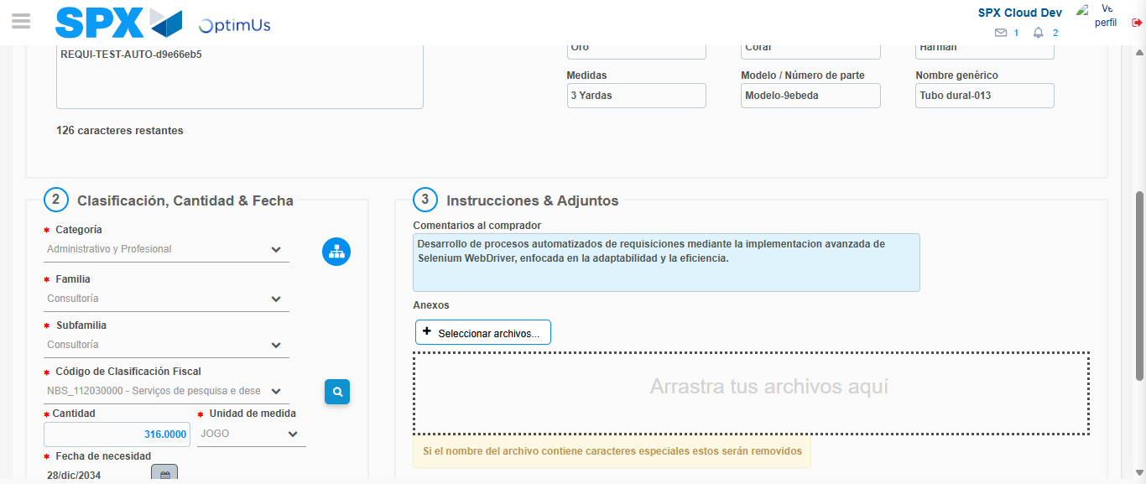Image file-name: QC_Testing-tc002_SPX_Dev5_Crear_Requisicion_Spot_Con_FAD_Tipo_Cobro_CC-1790178773323

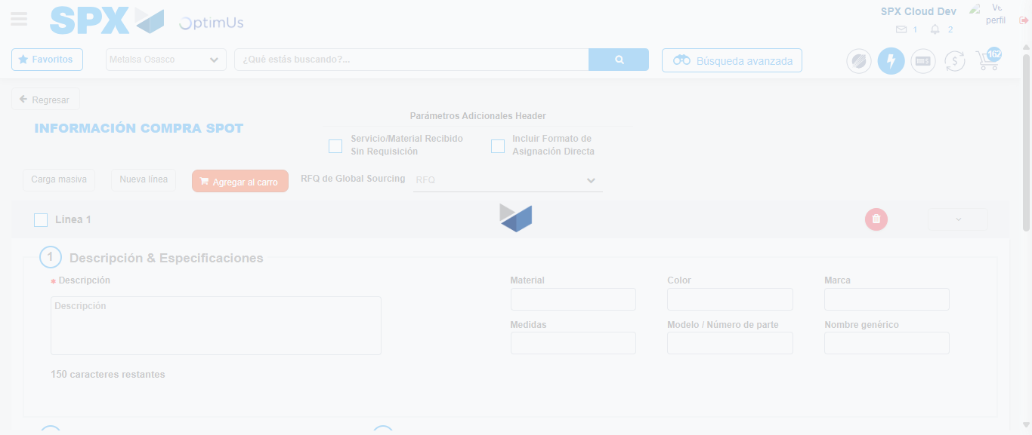Image file-name: QC_Testing-tc002_SPX_Dev5_Crear_Requisicion_Spot_Con_FAD_Tipo_Cobro_CC-1790178785577

Step 8 - Return to Main Page SPX : Return to Main Page SPX
Image file-name: QC_Testing-tc002_SPX_Dev5_Crear_Requisicion_Spot_Con_FAD_Tipo_Cobro_CC-1790178713919

Image file-name: QC_Testing-tc002_SPX_Dev5_Crear_Requisicion_Spot_Con_FAD_Tipo_Cobro_CC-1790178714398

Image file-name: QC_Testing-tc002_SPX_Dev5_Crear_Requisicion_Spot_Con_FAD_Tipo_Cobro_CC-1790178719846

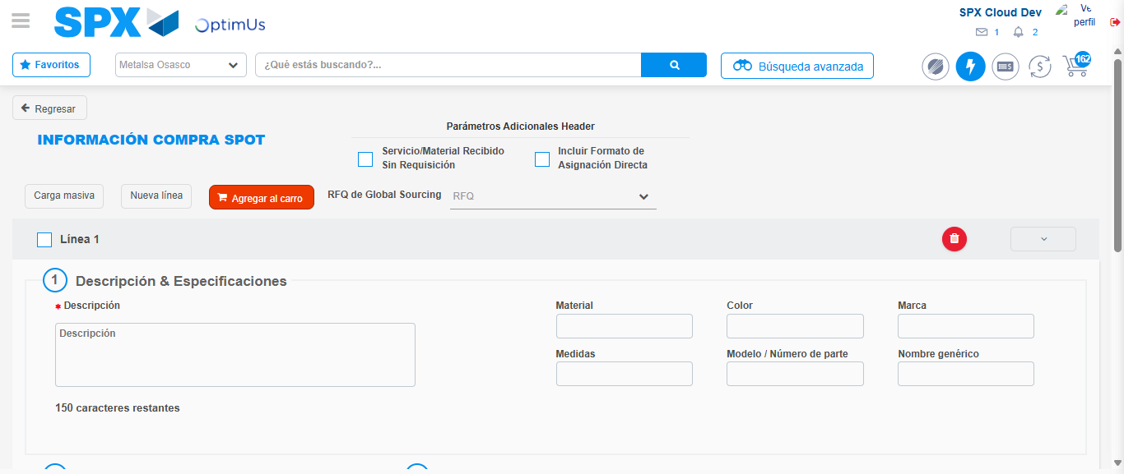Image file-name: QC_Testing-tc002_SPX_Dev5_Crear_Requisicion_Spot_Con_FAD_Tipo_Cobro_CC-1790178787762

Image file-name: QC_Testing-tc002_SPX_Dev5_Crear_Requisicion_Spot_Con_FAD_Tipo_Cobro_CC-1790178787918

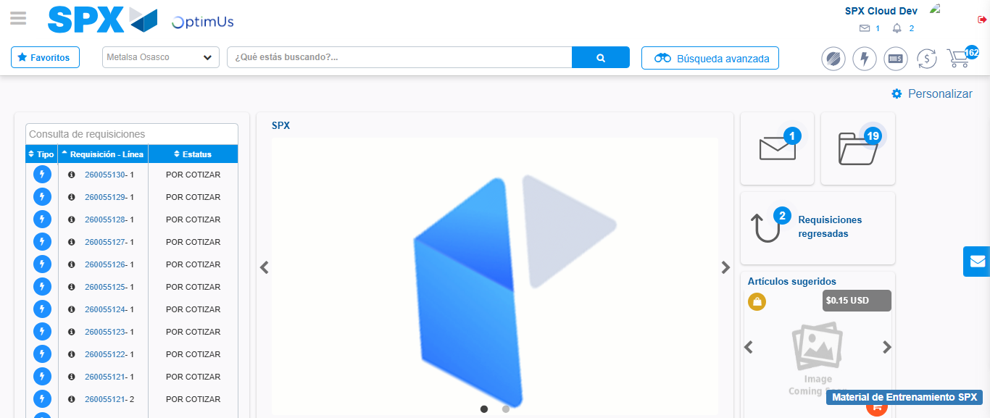Image file-name: QC_Testing-tc002_SPX_Dev5_Crear_Requisicion_Spot_Con_FAD_Tipo_Cobro_CC-1790178808992

Step 9 - Log Out : Log Out SPX
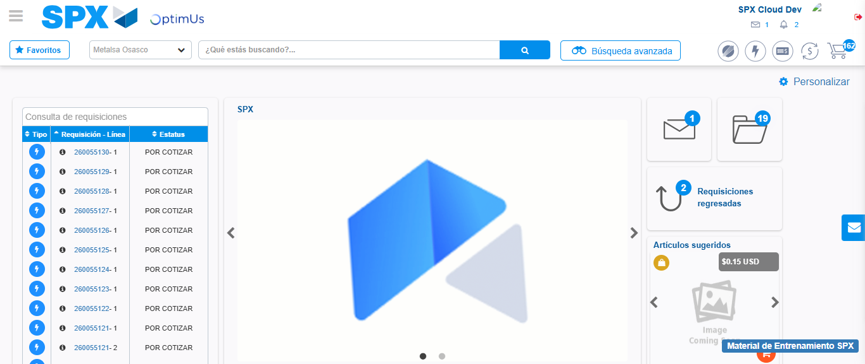Image file-name: QC_Testing-tc002_SPX_Dev5_Crear_Requisicion_Spot_Con_FAD_Tipo_Cobro_CC-1790178809266

